INFLUENCE OF PHOSPHORUS AND SULFUR NUTRITION ON COMPOSITION OF CLITORIA TERNATEA L.
by M. G. ZAROUG and D. N. MUNNS

Land, Air and Water Resources, University of California, Davis, CA 95616 USA

KEY WORDS

Nodulation Nitrate N-fertilization Plant P, S, N Sugar

SUMMARY

A greenhouse experiment on a silt loam surface soil (Typic Hapludult) was done to investigate effects of P and S on yield, quality aspects and sugar reserves in the tropical forage legume Clitoria ternatea L. Four levels of P and two N treatments (NH₄N0₃ vs symbiotic) were arranged in a factorial design with four replications. After the first cutting two levels of S were imposed on this design.
Phosphorus enhanced dry matter yield in the first cutting. Its effect was smaller in the second cutting. Amount of P required to produce maximum plant yield dropped from 200 mg/kg soil (or more) at the first cutting to 50-100 mg/kg at the second. Added S improved growth at suboptimal levels of P. At optimal P and S, symbiotic and +N plants yielded alike.
Phosphorus and S fertilization caused several changes in plant composition. Nitrogen concentration was raised by S treatment and lowered by P. Combined addition of P and S lowered plant nitrate content. In symbiotic plants, soluble sugar concentrations were higher than in N-treated plants, and were increased by P and S treatment. In N-treated plants, neither P nor S increased reducing sugar concentration, but they increased total sugar.
INTRODUCTION

Addition of S to legumes grown at low S conditions is known to affect N metabolism and protein synthesis¹. Increased concentrations of P may improve early establishment and function of nodules⁹, probably because of greater seedling growth¹⁸. Fertilization of forage legumes with P and S can improve not only yield but also quality aspects such as concentrations of P, S and protein N ^{1, 2, 3, 17}, and sugar concentration ^{6,15,16}.
In a previous study with the forage legume Clitoria ternatea L., P and S nutrition were found to affect nodulation, growth, soluble sugars and etiolated regrowth²². Response to P was prominent in early plant growth while response to S was greatest during regrowth after cutting. As both establishment and

251

Plant and Soil 55, 251-259 (1980). 0032-079X/80/0552-0251$01.35
© Martinus N~hoff Publishers, The Hague. Printed in The Netherlands.
252 M. G. ZAROUG AND D. N. MUNNS

regeneration after cutting are essential features for management of perennial forage plants, a better understanding of these nutrient effects is pertinent.
The aim of the experiment reported here was to assess effects of P and S nutrition on composition of Clitoria ternatea L., and relate these effects to differences in plant growth and regeneration after cutting.
MATERIALS AND METHODS
The experimental was initially a 4 x 2 factorial design in randomized blocks with four replicates for each treatment. There were four levels of P (0, 50, 100 and 200 ppm, referred to as P₁, P₂, P₃, P₄, respectively) and two N treatments (inoculated with no N fertilizer, or 200 ppm N as NH₄N0₃). All treatments received a basal dressing of Zn and Mo. The soil was a Josephine loam (Typic Hapludult), 0-30 cm, as described previously²². Clitoria ternatea seed were obtained from Sudan Ministry of Agriculture, Khartoum.
Five seeds, scarified with sandpaper, were planted in each pot containing 2 kg soil. In the inoculated treatment, each seed received 1 ml of a suspension containing 10⁴ viable cells of Rhizobium strain TAL173, obtained from the University of Hawaii NifTAL Project. Pots were watered to field capacity by weight with distilled water as needed. One week after emergence, plants were thinned to three per pot, and 100 ppm N was added to the + N pots. Another 100 ppm N was added 10 days later.
Eight weeks from planting, tops were cut, oven-dried and weighed. One day after cutting, half of the replicates received 15 ppm S as K2SO4 solution, and all the +N pots received another 200 ppm N. Then all pots were watered to field capacity. Five weeks from the first cutting, all pots were harvested again.
Tops were ground for analysis after drying and weighing. Percent N was determined by a microKjeldahl procedure¹², nitrate with phenol disulphonic acid¹¹, S by sulfate reduction¹¹ after dry ashing with silver oxide ²⁰, P by a molybdate blue procedure¹¹, and total and reducing sugars by A.O.A.C. procedure⁴.
RESULTS AND DISCUSSION

Dry matter accumulation

In both cuttings, P treatment increased yields of both symbiotic and + N plants (Tables 1 and 2). The increases were progressive and significant over most of the range of P addition in the first cutting. In the second cutting, the amount of P required for maximal yield diminished to a level between 50-100 ppm. Similar findings have been reported for some other legumes^{7,} ¹⁴. The shift in added P requirement was not accompanied by decrease in plant P and was not due to exhaustion of S. It is possible that the root system became well established during the first period of growth, hence the plant requirement for P was mainly for shoot growth. In many instances yield responses were paralleled by responses in P concentration in the shoot tissue (Table 1 and 2).
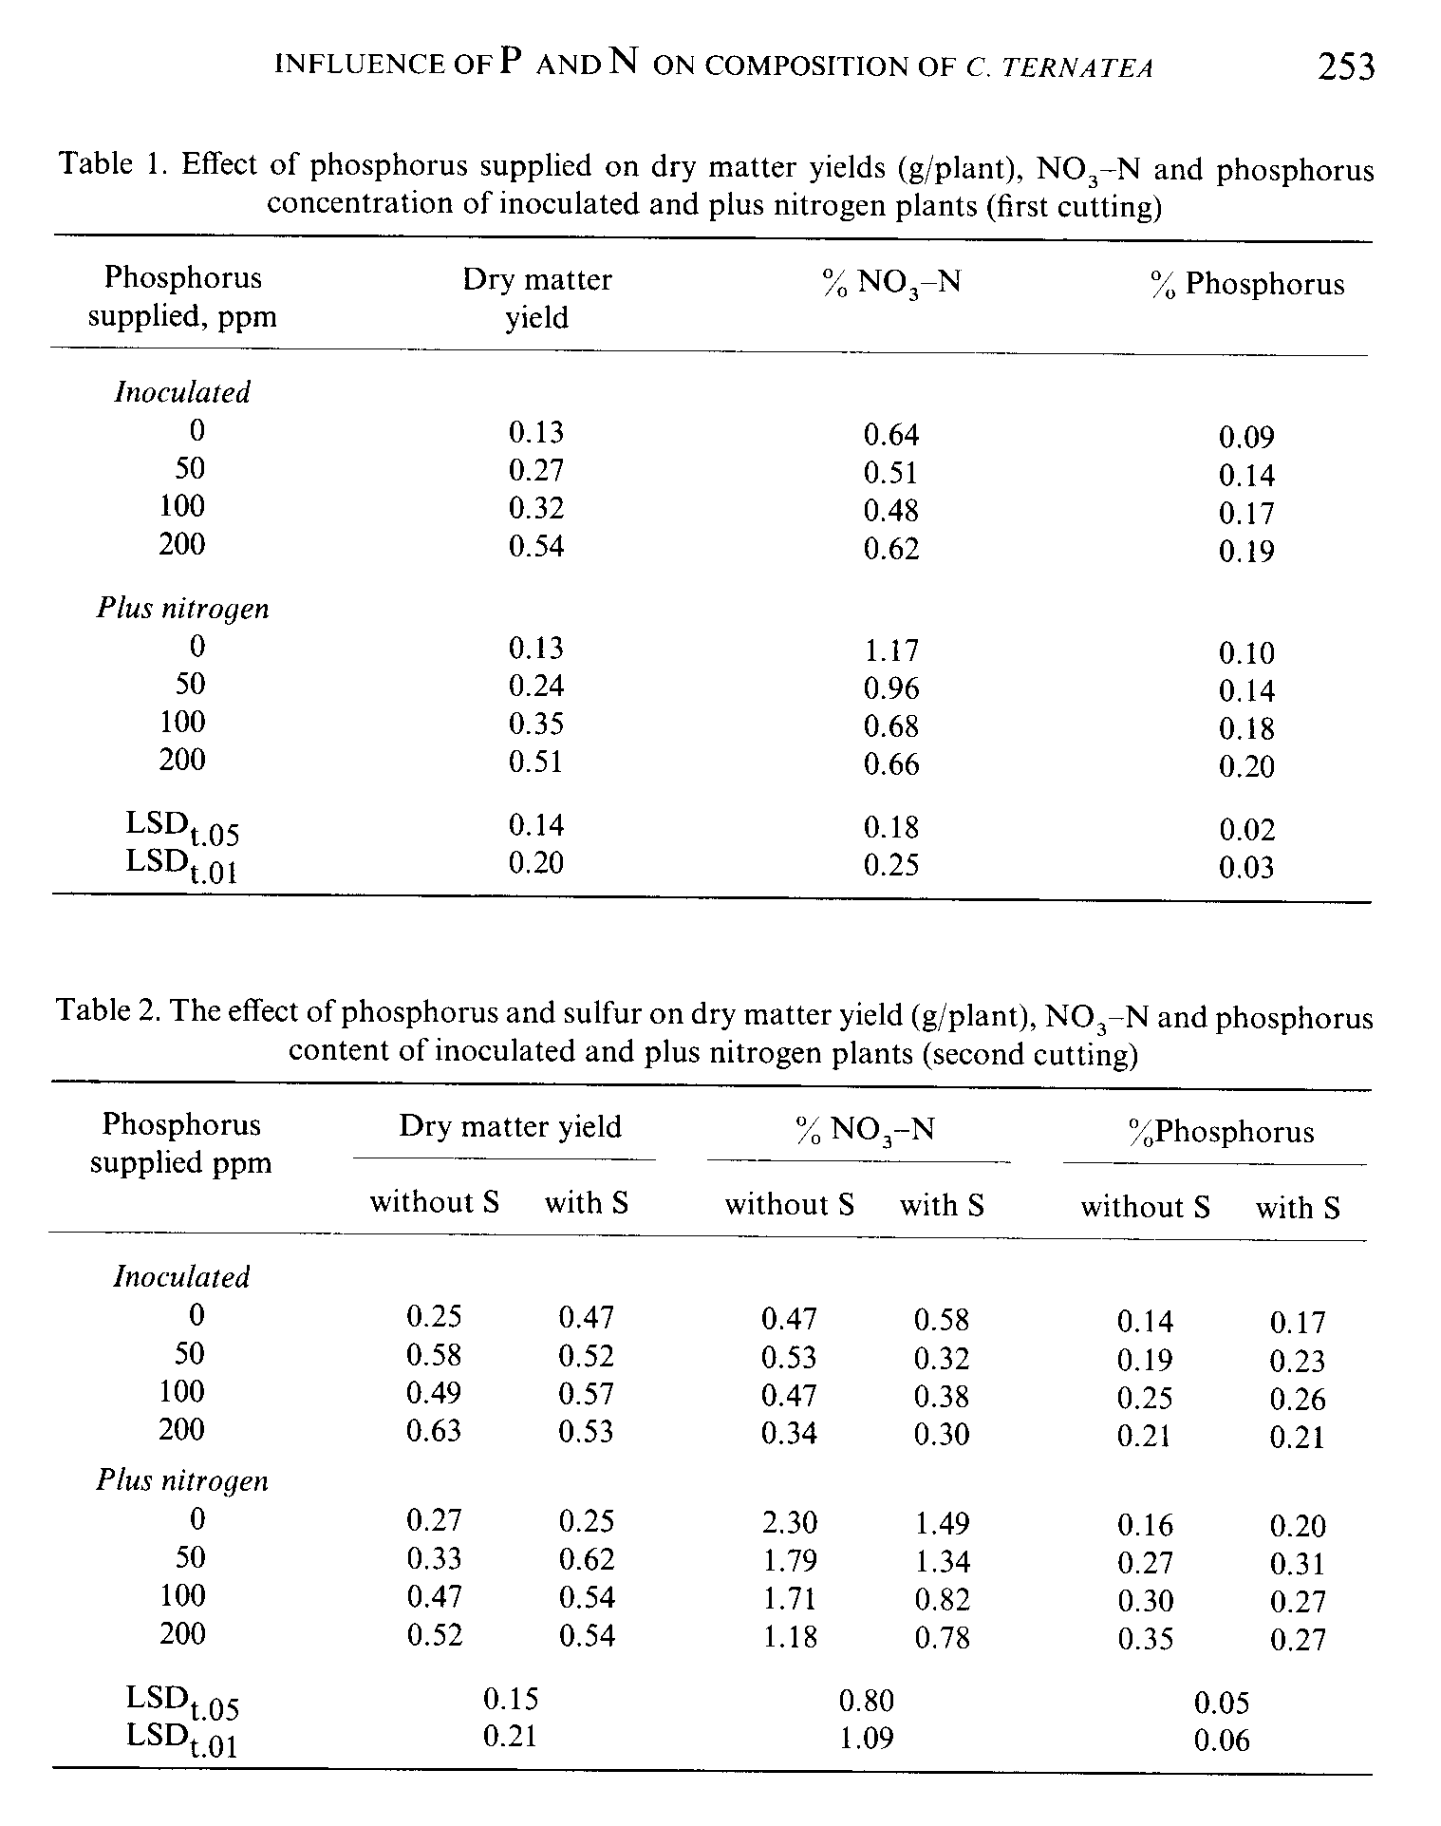
Sulfur deficiency symptoms (chlorosis) were observed in the first growth period only in the highest-yielding, P₄, treatment, and the relationships between yields and S concentrations were inverse (Table 1 and Fig. 1). In the second cutting, S deficiency symptoms appeared at all P levels, especially in + N plants. Yield responded to S only at certain suboptimal levels of P.
INFLUENCE OF P AND N ON COMPOSITION OF C. TERNATEA 255
Inorganic N addition did not increase yields of dry matter over that from symbiotic plants. Indeed, without added S the symbiotic plants outyielded the + N plants at most P levels supplied (Table 2).
Total and nitrate N

Total N declined gradually with increasing P supplied to both symbiotic and + N plants (Fig. 2). This contrasts with results of Andrew and Robins ², where N concentrations in several legumes were increased by P fertilization. Clitoria ternatea L. might have a tendency to accumulate N under growth-limiting stress.
Nitrate was much higher in + N plants than in symbiotic plants. Adding P to + N plants consistently depressed their nitrate concentration (Table 1, 2).
In the regrowth, S addition caused marked differences in total and nitrate N (Fig. 2 and Table 2). Total N concentration in symbiotic plants increased in accordance with other findings^{1,3,13}. Nitrate N was slightly lowered. In + N plants, S caused a large decrease in nitrate, enough to account for the decrease in total N. Accumulation of nitrate in S-deficient plants has been reported^{1,13}.
Sulfur and phosphorus

In both cuttings, increasing the supply of P lowered the S concentration in the shoots (Fig. la, b). Correlations between plant S and plant P were negative (r = -0.91, P < 0.01 in first cutting, r = -0.54, P < 0.05 in second cutting). Addition of S in the second period increased plant S; but S concentration was highest in the stunted zero P plants.
Phosphorus concentration in the tops increased with each increment of P supplied in the first cutting, but only with the first one or two increments in the second cutting (Table 2). There were no significant differences in P concentrations between symbiotic and + N plants at the four rates of P in the first cut, but in the second cut with addition of P the + N plants generally had higher P concentration than symbiotic plants, and any plants of the first cutting. This is consistent with the suggestion that the plants become, with age, better able to acquire soil P.

Soluble sugar

Concentrations of reducing sugar were low, less than 0.5%, in roots and stubble of N-treated plants, and were little affected by P or S. By contrast, reducing sugar was higher in symbiotic plants, and here it increased with addition of S and with
addition of P up to level P₃ (Fig. 3a). Rendig and McComb¹⁵ found no significant difference in the concentrations of reducing sugars in shoots of alfalfa grown with various S levels, but in a separate study ¹⁶ they found that shortage of S decreased the concentration of reducing sugar especially glucose in the stems. The latter effect was detected through use of chromatographic techniques rather than the regular Somogyi method used previously.
Total and non-reducing sugar behaved alike, hence, only total sugar is presented in Fig. 3b. Addition of S increased total sugar content (Fig. 3b), agreeing with evidence that it increased incorporation of ¹⁴C0₂ into glucose, fructose and sucrose⁶. Dry matter yield and S content for the second cutting correlated significantly (P < 0.05) with total sugar concentration (r = 0.60 and r = 0.49, respectively). Given S, symbiotic plants had almost 40% more total sugar than + N plants at any P level supplied. These differences between the two N levels were significant (Fig. 3b). They might imply that large net consumption of photosynthate for N₂ fixation¹⁰ is not universal to all legumes under various growth conditions.

Symbiotic performance

Similarity of dry matter yields of symbiotic and + N plants in the first cutting and general superiority of symbiotic plants in the second cutting, suggests that
INFLUENCE OF P AND N ON COMPOSITION OF C. TERNATEA 257

the symbiosis was highly effective or that Clitoria ternatea L. had difficulty utilizing mineral N for better growth even when S was supplied. The accumulation of nitrate in the tissue may indicate the latter. It precludes the possibility that N supply to the plants was limiting in the + N treatments, especially since uptake was never greater than 25% of the N added to the soil, and there was no leaching. High symbiotic effectiveness of Clitoria ternatea L. was confirmed in a separate study, where plants inoculated with each of four Rhizobium strains (TAL173, 29B2, TAL200NA, TAL305) all outyielded plants given 200 ppm N as NH₄N0₃ (M. G. Zaroug, unpublished).
Significance of effects on composition
Concentrations of P in the shoots reflected the dominant effects of P-supply on growth. The nitrogen concentration data argue against any important direct effect of P on nodulation (Fig. 2). For a given level of P supplied, the concentration of P in the plant was greater in the second cut, probably because of better exploration of the soil. Nitrogen and S noticeably lowered plant P at levels P₃ and P₄ in the second cut. This may indicate some antagonistic effect in uptake. It was not a result of differential onset of flowering, as found by Robinson and Jones¹⁷ for Stylosanthes, because all P treatments flowered within a three day period when S was supplied.
The highest P level, P₄, lowered total sugar concentration (Fig. 3b). No firm explanation can be offered, but the effect has been observed before²². Most other effects of P were probably the consequence of dilution by increased dry matter. These include the decreases in total N, nitrate and S.
Both S and N influenced soluble sugars. The increase in sugars due to S addition was possibly simply a consequence of greater photosynthesis⁶. The reduction in sugar level by N-addition may have been due to increased root production and consequently a greater sink for carbohydrate¹⁹. Whatever the reason for lower sugar in + N than symbiotic plants, it is inconsistent with the supposition that N₂ fixation lowers and is limited by carbohydrate supply ¹⁰.
However, in Clitoria ternatea L. as in other legumes, carbohydrate reserves in nodules and roots may be important for sustaining nitrogenase activity during the night and during periods of low light intensity⁵. The reserves are also important for regeneration after cutting and for competitive efficiency in mixed stands. This may emphasize the need for enhancing food reserves of storage organs by judicious fertilization and management.
The increase in total N when symbiotic plants were supplied with S probably related to enhanced protein synthesis¹ and nodulation^{1,} ⁹. In + N plants, S
258 M. G. ZAROUG AND D. N. MUNNS
lowered N concentration in the plant, probably because it eased a restriction on protein synthesis^{1,8,15} and lowered the accumulation of soluble N^{8,13,16}, including nitrate in this case.
Reduction of nitrate levels when P or S were added might also be partly attributable to higher total sugar, as suggested by Wright and Davidson 21, in addition to the major effect of dilution by the stimulated growth. Accumulation of nitrate in + N plants suggests that rate of assimilation had not kept pace with rate of uptake. The values of nitrate in the top material from the + N plants could be hazardous to livestock; they compare with lethal values of 0.6 to 3.5% N0₃ -N quoted for other plants²¹.
ACKNOWLEDGEMENTS
This work was partly supported by the U.S. Agency for International Development through the University of Hawaii NifTAL Project.
Received 3 September 1979.
LITERATURE CITED
1 Anderson, A. J. and Spencer, D. 1950 Sulfur in nitrogen metabolism of legumes and nonlegumes. Aust. J. Sci. Res. 3, 431-449.
2 Andrew, C. S. and Robins, M. F. 1969 The effect of phosphorus on the growth and chemical composition of some tropical legumes. I. Growth and critical percentages of phosphorus. Aust. J. Agric. Res. 20, 665-674.
3 Andrew, C. S. 1977 The effect of sulfur on the growth, sulfur and nitrogen concentration of some tropical and temperate legumes. Aust. J. Agric. Res. 28, 807-820.
4 Association of Official Analytical Chemists. 1970 Methods of Analysis, 11th Ed. Washington, D.C.
5 Bergersen, F. J. 1976 Physiological chemistry of dinitrogen fixation by legumes. In A Treatise on Dinitrogen Fixation III. R. W. F. Hardy and W. S. Siler John Wiley and Sons, New York.
6 Chen, C. L. H. 1967 Assimilation of ¹⁴CO₂ by Medicago sativa leaves in relation to sulfur nutrition. Ph.D. Thesis, University of California, Davis.
7 Fox, R. L., Nishimoto, R. K., Thompson, J. R., and de la Pena, R. S. 1976 Comparative external phosphorus requirements of plants growing in tropical soils. Trans. 10th Int. Congr. Soil Sci. Moscow, U.S.S.R. 4, 232-239.
8 Gates, C. T., Wilson, J. R. and Shaw, N. H. 1966 Growth and chemical composition of Townsville lucerne (Stylosanthes humilis) Aust. J. Exp. Agric. Anim. Husb. 6, 266-276.
9 Gates, C. T. 1974 Nodule and plant development in Stylosanthes humilis H.B.K.: Symbiotic response to phosphorus and sulfur. Aust. J. Bot. 22, 45-55.
10 Hardy, R. W. F. and Havelka, V. D. 1975 Nitrogen fixation research: a key to world food. Science 188, 633-643.
11 Johnson, C. M. and Ulrich, A. 1959 Analytical methods for use in plant analysis. Calif. Agric. Exp. Stn. Bull. 766.
12 Mckenzie, H. A. and Wallace, H. S. 1954 Kjeldahl determination of nitrogen: a critical study of digestion conditions. Aust. J. Chem. 7, 55-70.
INFLUENCE OF P AND N ON COMPOSITION OF C. TERNATEA 259

13 Pasricha, N. S. and Randhawa, N. S. 1975 Effect of sulfur fertilization on the nitrogen metabolism in Berseem. Indian J. Agric. Sci. 45, 213-218.
14 Plucknett, D. L. and Fox, R. L. 1965 Effect of phosphorus fertilization on yield and composition of pangola grass and Desmodium intortum. Proc. 9th Int. Grassl. Congr. 1525-1529.
15 Rendig, V. V. and McComb, E. A. 1959 Effect of nutritional stress on plant composition. I. The interaction of added nitrogen with varying sulfur supply. Soil Sci. Soc. Am. Proc. 23, 377-380.
16 Rendig, V. V. and McComb, E. A. 1961 Effect of nutritional stress on' plant composition. Plant and Soil 14, 176-186.
17 Robinson, P. J. and Jones, R. K. 1972 The effect of phosphorus and sulfur fertilization on the growth and distribution of dry matter, nitrogen, phosphorus and sulfur in Townsville Stylo Aust. J. Agric. Res. 23, 633-640.
18 Robson, A. D. 1978 Mineral nutrients limiting nitrogen fixation in legumes. In Mineral Nutrition of Legumes in Tropical and Subtropical Soils. Eds. C. S. Andrew and E. J. Kamprath CSIRO, Melbourne, Australia.
19 Small, J. G. C. and Leonard, O. A. 1969 Translocation of ¹⁴C-labelled photosynthate in nodulated legumes as influenced by nitrate nitrogen. Am. J. Bot. 56, 187-194.
20 Steinbergs, Iismaa, A. O., Freney, J. R. and Barrow, N. J. 1962 Determination of total sulfur in soil and plant material. Anal. Chim. Acta 27, 158-164.
21 Wright, M. J. and Davidson, K. L. 1964 Nitrate accumulation in crops and nitrate poisoning in animals. Adv. Agron. 16,197-247.
22 Zaroug, M. G. and Munns, D. N. 1980 Effects of phosphorus and sulfur nutrition on soluble sugar and growth of Clitoria ternatea L. Plant and Soil 55, 243-250.

